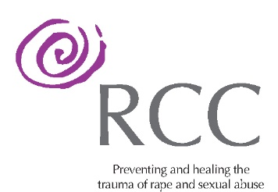

APPLICATION FORM

PSYCHOTHERAPIST
PART-TIME

Name:

Address:

Mobile number:

Email Address:

Linkedin profile: Yes ☐ No ☐

Our Mission and Values are at the heart of the Service we provide and can be accessed via the following link. Please take the time to read prior to completing the Application Form.

https://www.drcc.ie/about/

1.Please list your qualifications

Year  From - To | Award | Awarding Body | Year of  Award

2.Please state your education and training background

3(a) Please state your psychotherapy experience, including specific sexual violence work?

3(b) Group Work Experience

4. Do you have any experience of working with community/voluntary sector?

5.What is your definition of rape?

6.What is your definition of child sexual abuse?

7.What is your experience of personal therapy?

8. What qualities do you think you can bring to the Dublin Rape Crisis Centre?

9.Why would you like to work at the Dublin Rape Crisis Centre?

10 (a) Are you accredited with:

IAHIP Yes ☐ No ☐
ICP (any modality) Yes ☐ No ☐
I.A.C.P. Yes ☐ No ☐

10 (b) Please give details, including date of accreditation.

11. Are you available to work early mornings or late evenings, and in Outreach
Services?

12. Do you anticipate that you would need support in your own life as a result of your work in the Centre?

If so, where do you anticipate this coming from?

13. How do you like to spend your free time?

14. Is there anything you would like to add?

15. Declaration

Candidates are required to declare prior abuse convictions and whether they have been or ever having been the subject of any investigation or enquiry into abuse or other inappropriate behaviour. Please declare any relevant details below.

Referees

Please give the names and addresses of three referees (with phone numbers) who can be contacted for both a written and verbal reference and please include a Curriculum Vitae.

Referee 1:

Referee 2:

Referee 3:

Please note, background checks and detailed consideration of references coupled with mandatory Garda Vetting will be undertaken. Applicants must be authorised to work lawfully within the EU. We cannot sponsor applicants for work visas.

Please return the completed form, with current CV to:

recruitment@rcc.ie Subject line PSYCHOTHERAPIST PART-TIME

Closing date:

Expected dates of interviews:

