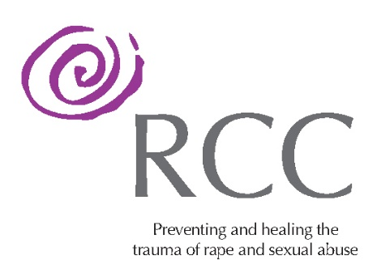

Are you seeking a new challenge, with an openness to acquiring new skills?
This dynamic new role could be for you

The Dublin Rape Crisis Centre
is now recruiting two
THERAPY INTAKE COORDINATORS
Background
The DRCC is committed in working to heal the trauma and prevent the harm of sexual violence in our society.
We have been expanding our service substantially in recent years and in response to heightened demand for our services have been successful in creating a range of innovative supports and activities.
Given the continuous growth in demand for our therapy services, DRCC is now offering an exciting new opportunity to join its dynamic team within its therapy structure.
These new positions work within the Therapy Team, reporting to the Therapy Service Manager.
The successful candidates will facilitate the intake process, overseeing progression of individuals from the waiting list to ongoing therapy, in line with DRCC’s commitment to deliver an effective, efficient and client-centred therapy service.
The Role
The successful candidates will be responsible for processing the intake of all potential clients of DRCC, in consultation and collaboration with the Therapy Service Manager, including:
- Conducting assessments of potential clients.
- Completing assessment tools, forms and other relevant documentation.
- Ensuring implementation of risk management strategies.
- Providing support and crisis intervention when necessary.
- Checking in with assessed individuals on waiting list.
- Liaising with Therapy Service Manager on appropriate allocation of potential clients to therapists.
- Regular monitoring of the waiting list.
- Ensuring input and updating of data in CRM
- Ensure file management is in line with GDPR, data protection and confidentiality policies and regulations.
- Maintaining knowledge of other services and referral options as well as with DRCC policies & procedures.
- Ensuring all individuals are met with compassion, empowerment and respect in line with DRCC’s values.

Essential,
- Be fully accredited with IAHIP, IACP, ICP, PSI.
- Substantial therapeutic experience, (minimum 5 years) in the area of trauma, sexual violence and abuse.
- Have experience working therapeutically with diverse presentations.
- Substantial knowledge and experience of working with mental health disorders.
- Experience of carrying out clinical assessments.
- Excellent communication and interpersonal skills.
- High competency and a good working knowledge of IT systems.

If you are interested in developing and progressing your career in Psychotherapy within a dynamic, innovative environment, this role could be your opportunity.

All prospective employees are required to declare prior convictions and whether they have been the subject of any investigation or enquiry into abuse or other inappropriate behaviour. Gardaí Vetting is a requirement.

We welcome applications from people from all sections of the community, irrespective of race, colour, gender, age, disability, sexual orientation, religion or belief.

